Dear user,

For the below requested software installation you will receive a pop-up , as stated below. Kindly wait for the same. If you haven’t received the pop-up yet, please check your software Center in your machine, the requested software will be available.

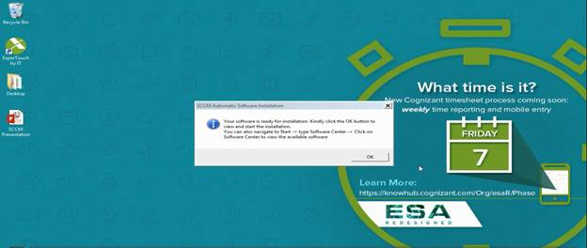

Please click OK for Software Center (a Pre- installed application) to open.

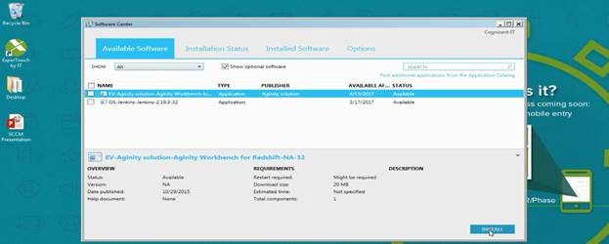

Select the software that has to be installed, from the list and click INSTALL button.

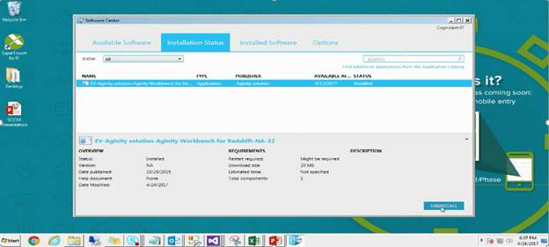

The software will be installed in few minutes.

Hi Ramesh,

We believe, you would have received a mail from “One Communicator”, carrying detailed instruction on installation of the application requested thru “Software Center”, as shown below.

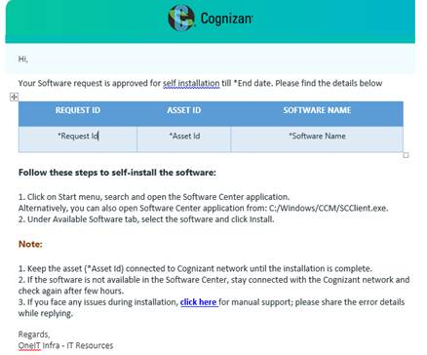

Please select the “click here” button, provided with the mail to open a comment box.

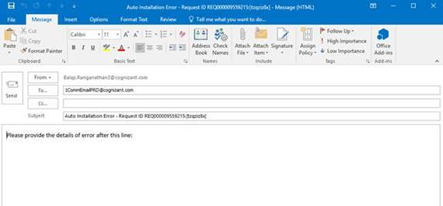

Provide details of the error message that you had received on installation of the tool, thru Software Center and hit send.

The request will be moved to manual queue and our analyst will reach you to have the software installed with your machine.